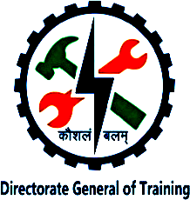

NATIONAL SKILL TRAINING INSTITUTE (NSTI) KOLKATA, DASNAGAR, HOWRAH

LESSON PLAN
NAME: Ankita singh TRADE/ROLL NO: 1420
UNIT/LESSON NO. :5 DATE & TIME : 29/10/25
- PREPARATION

TITLE/TOPIC: SWITCHING

OBJECTIVES: At the end of the lesson trainee shall able to -
a) Basics of switching .
b) Different types of Switching techniques .
TEACHING AIDS : WHITE BOARD, MARKER, PROJECTOR, PPT. PENDRIVE, ETC.
INTRODUCTION:
Define through examples
- PRESENTATION
OBJECTIVES | INFORMATION POINTS | SPOT HINTS
Define switching  Types of Switching Techniques: | Switching is the process of directing data traffic between devices in a network efficiently.  A switch uses MAC addresses to decide where to send data inside a Local Area Network (LAN).  TYPES :  Circuit Switching:  - Dedicated communication path.  - Example: Traditional telephone networks.  Packet Switching:  - Data broken into packets; each may take different routes.  - Example: The Internet. | 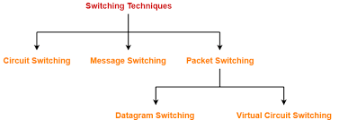  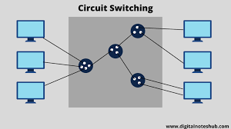

OBJECTIVES | INFORMATION POINTS | SPOT HINTS
 | Message Switching:  - Entire message sent, stored, and forwarded.  - Example: Early telegraph networks.  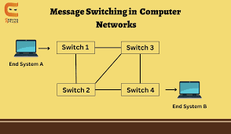 | 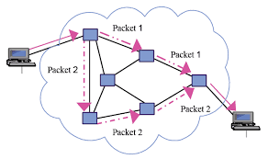
- APPLICATION :
a) What is switching ?
b) Name the different types od switching techniques ?
c) Give real-life examples of each switching type.

SUMMARY : To repeat the objectives/main points once again.
Repeat the step second in short.

- TEST/QUESTIONS :
a) Define switching.
b) Explain how a switch learns MAC addresses.
c) Compare: Hub vs. Switch vs. Router.

ASSIGNMENT:
Research and report: “How do data centers use network switches?”

Reference: Computer network textbook

NEXT LESSON: INTERNET PROTOCOL

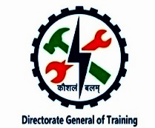

NATIONAL SKILL TRAINING INSTITUTE (NSTI) KOLKATA, DASNAGAR, HOWRAH

INFORMATION SHEET

TOPIC:SWITCHING
INFORMATION:
DEFINITON
Switching is the process of transferring data or information between computers or devices within a network by choosing the most efficient path for data to travel from the source to the destination.

It is performed by network devices called switches or routers, which receive data, examine its destination address, and forward it only to the intended device or network segment — not to all devices.

TYPES OF SWITCHING TECHNIQUES
🧠 Types of Switching Techniques

Switching techniques are methods used to transfer data between devices in a network.
There are three main types of switching techniques used in communication networks:
1. Circuit Switching
2. Packet Switching
3. Message Switching

🔹 1. Circuit Switching
📘 Definition:
Circuit switching is a method in which a dedicated communication path is established between the sender and the receiver before they start transmitting data.
The path remains reserved for that communication until the entire data transfer is completed.

⚙ How It Works:
1. The sender requests a connection to the receiver.
2. A dedicated circuit (path) is established through the network.
3. Data is transmitted continuously along this path.
4. After the communication ends, the circuit is released.
💡 Example:
Telephone networks use circuit switching.
When you make a phone call, a dedicated line is set up between you and the person you’re calling.
No one else can use that line until the call ends.
✅ Advantages:
- Reliable And ordered delivery of data.
- Constant data transfer rate.
- Simple communication once the circuit is established.
❌ Disadvantages:
- Inefficient — the path stays reserved even when no data is being sent.
- Not suitable for bursty (intermittent) data like Internet traffic.
- Setup time is longer.

🔹 2. Packet Switching
📘 Definition:
Packet switching is a method where data is divided into small packets, and each packet is sent independently through the network.
Each packet may take a different route, and they are reassembled at the destination in the correct order.
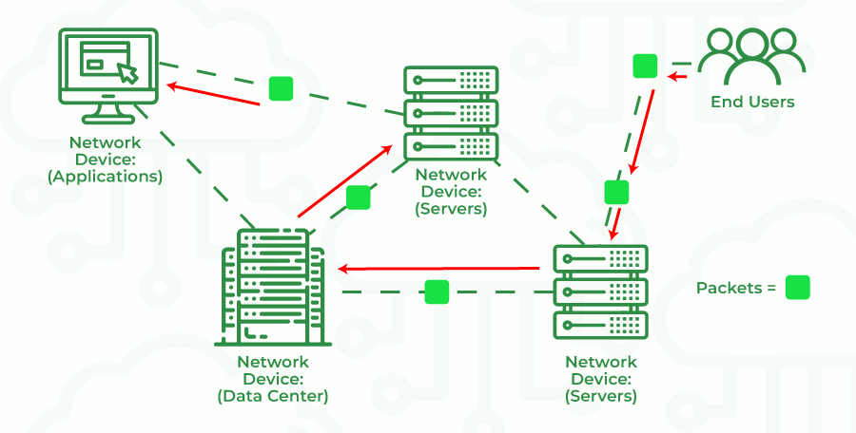

⚙ How It Works:
1. The message is split into packets (small units of data).
2. Each packet carries:
Source address
Destination address
Sequence number (for reordering)
3. Packets travel independently through various paths.
4. At the destination, packets are reassembled into the original message.
💡Example:
Internet communication (e.g., sending an email, browsing a website).
Each data packet may travel through different routers before reaching its destination.
✅ Advantages:
- Efficient use of network bandwidth.
- Multiple users can share the same channel.
- If one route fails, packets can take another path.
- Faster for short messages.
❌ Disadvantages:
- Packets may arrive out of order.
- More complex error detection and reassembly process.
- Possible delay (latency) due to congestion.
🧩 Types of Packet Switching:
1. Datagram Packet Switching:
Each packet is treated independently, and no fixed path is established. (Used in the Internet)
2. Virtual Circuit Packet Switching:
A logical path is established before sending packets, but it’s not physically dedicated. (Used in Frame Relay networks)
🔹 3. Message Switching
📘 Definition:
In message switching, the entire message is sent as a single unit from one node to another.
Each node stores the entire message temporarily, checks it, and then forwards it to the next node.
Hence, it is also known as the “store and forward” technique.

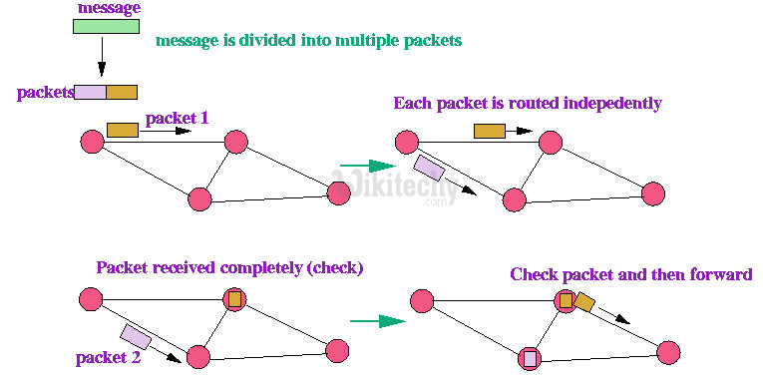

⚙ How It Works:
1. The whole message is created by the sender.
2. It is sent to the first node.
3. The node stores the message in memory, verifies it, and forwards it to the next node.
4. This continues until the message reaches its destination.
💡 Example:
Email systems or older telegraph networks use message switching.
Each message is stored at intermediate servers before reaching the recipient.
✅ Advantages:
- No need for a dedicated path.
- Efficient for long messages.
- Can handle messages of different sizes.
❌ Disadvantages:
Requires large storage at intermediate nodes.
High delay due to store-and-forward process.
Not suitable for real-time communication.

